

Web Technologies (Lab)
Assignment No. 02

Submitted to: Sir Usman Akram
Submitted by: Momina Kashif
Roll no: FA24-BCS-057
Class: BCS-B

Mobile view: 400px
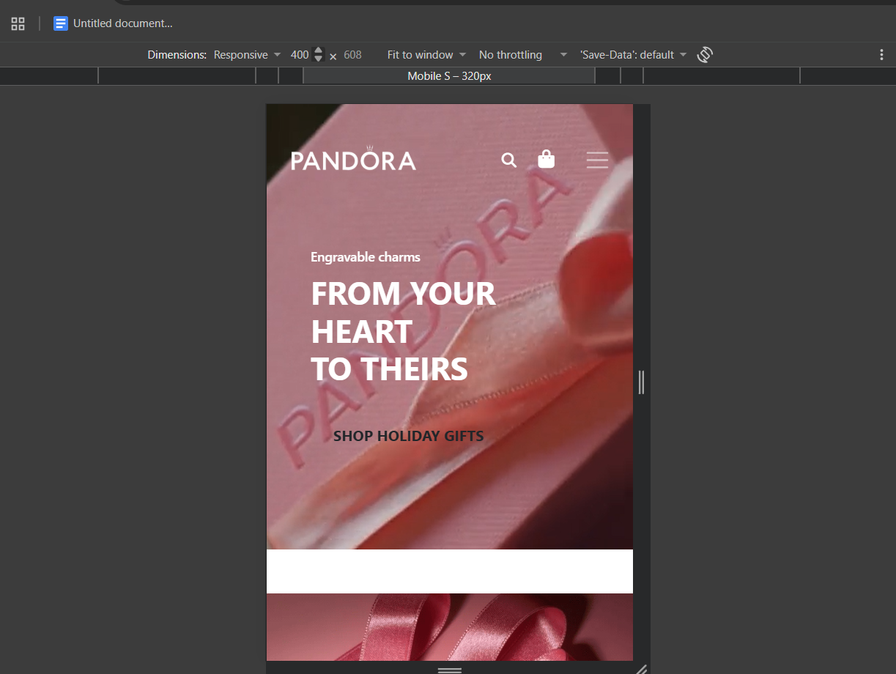

Tablet View: 768px
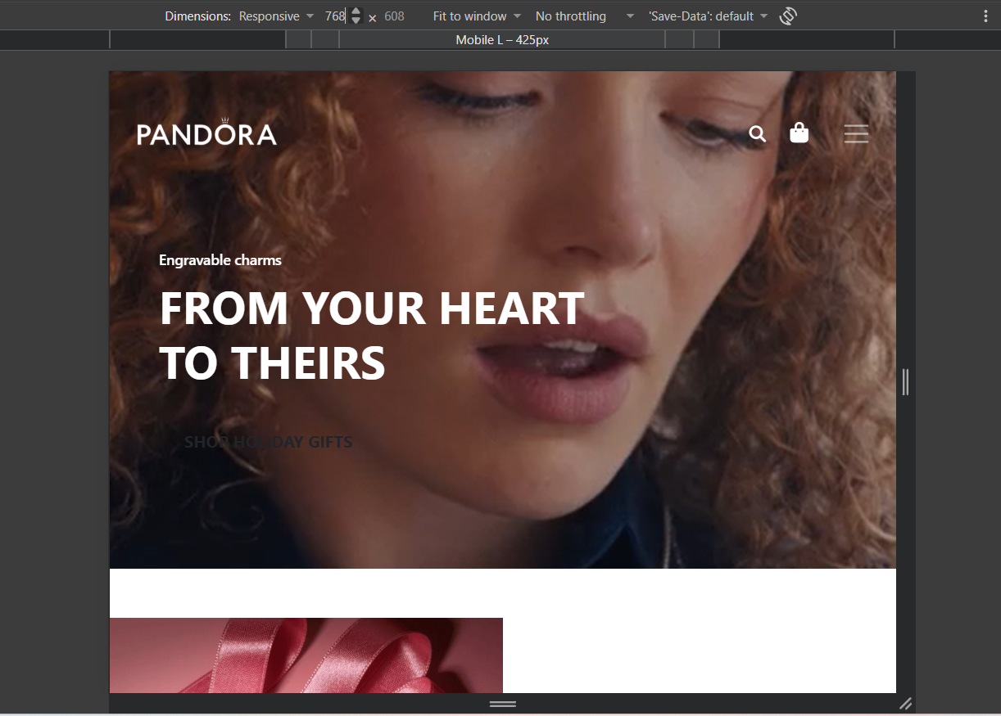
Desktop View: Full Width


